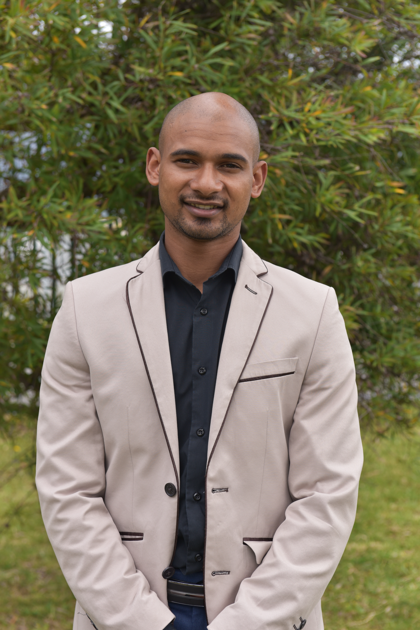

**Inspired full - stack Developer**

specializing in front end and back end development. Well-versed in numerous programming languages including HTML5, PHP, JavaScript, CSS, MySQL, Python.

# Experience

2014 to 2014

**Company: L&G Precision & Engineering (Maintenance)**

* Admin
* Maintenance
* Drawing of plans.
* Machining

2016 to 2018

**Company : MacNiel (Maintenance)**

* Admin
* Maintenance
* Machining

**Company : MacNiel (Maintenance)**

* Admin
* Maintenance
* Machining

# Education

2013

**Matric : Bellville Technical High School (HTS)**

2014

**N1 Certificate : College of Cape Town (Civil engineering) (Thornton) (Not completed)**

2019

**Certificate : University Of Western Cape (UWC) (Substance Abuse) (Completed)**

# Certifications

**PHP Framework (certificate):** Zend, Codeigniter, Symfony.

**Programming Languages:** JavaScript, HTML5, PHP OOP, CSS, SQL, MySQL.

# References

References available on request

**Phone:**

+27 81 539 2847

**E-Mail:**

shanemorne@gmail.com

**Linkedin:**

htpps://linkedin.com/in/shane-kolkoto-13b031120

**Github:**

https://github.com/Shane-kolkoto

**Portfolio website:**

[https://flamboyant-fermat-5528c4.netlify.app](https://flamboyant-fermat-5528c4.netlify.app/)

# Skill Highlights

* Music
* Soccer
* Gaming
* Rugby
* Reading
* Coding

# Languages

English – Home Language

Afrikaans – Second Language

SHANE MORNE KOLKOTO